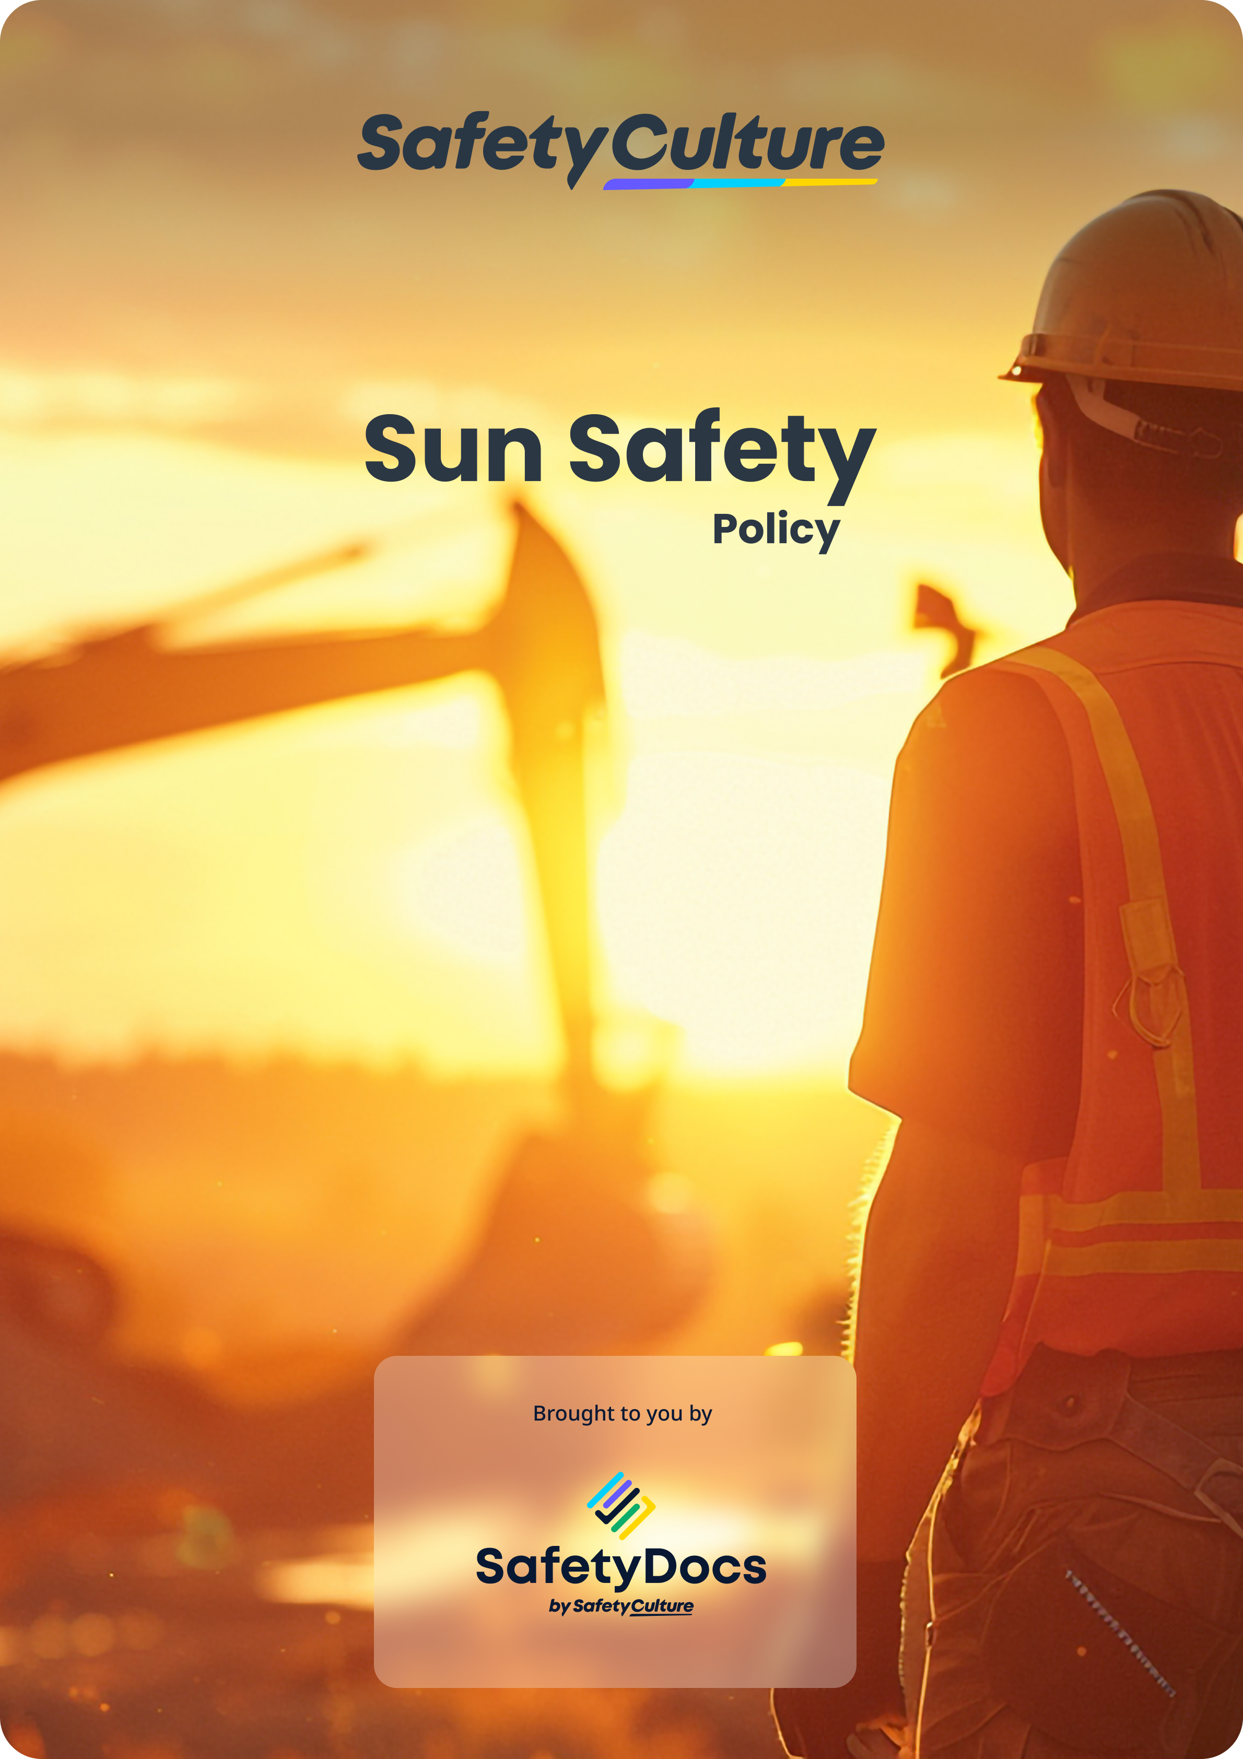
(REMOVABLE FIRST PAGE)

Sun Safety Policy
(Add your preferred heading)
+
(add your company logo here)

Company name
Company address
ABN/NZBN
Disclaimer: This document contains material to assist in addressing Occupational Health and Safety management obligations. Although every effort has been made to ensure the accuracy of this information at the time of publication, it is provided as guidance only. It does not provide legal advice on meeting your obligations.
This template is being provided as part of a limited-time campaign in recognition of the World Day for Health and Safety at Work on April 28, 2024. The provision of this template does not entitle the user to updates, revisions, or ongoing support from SafetyCulture or its related entities.
Copyright © SafetyCulture All Rights Reserved
  - 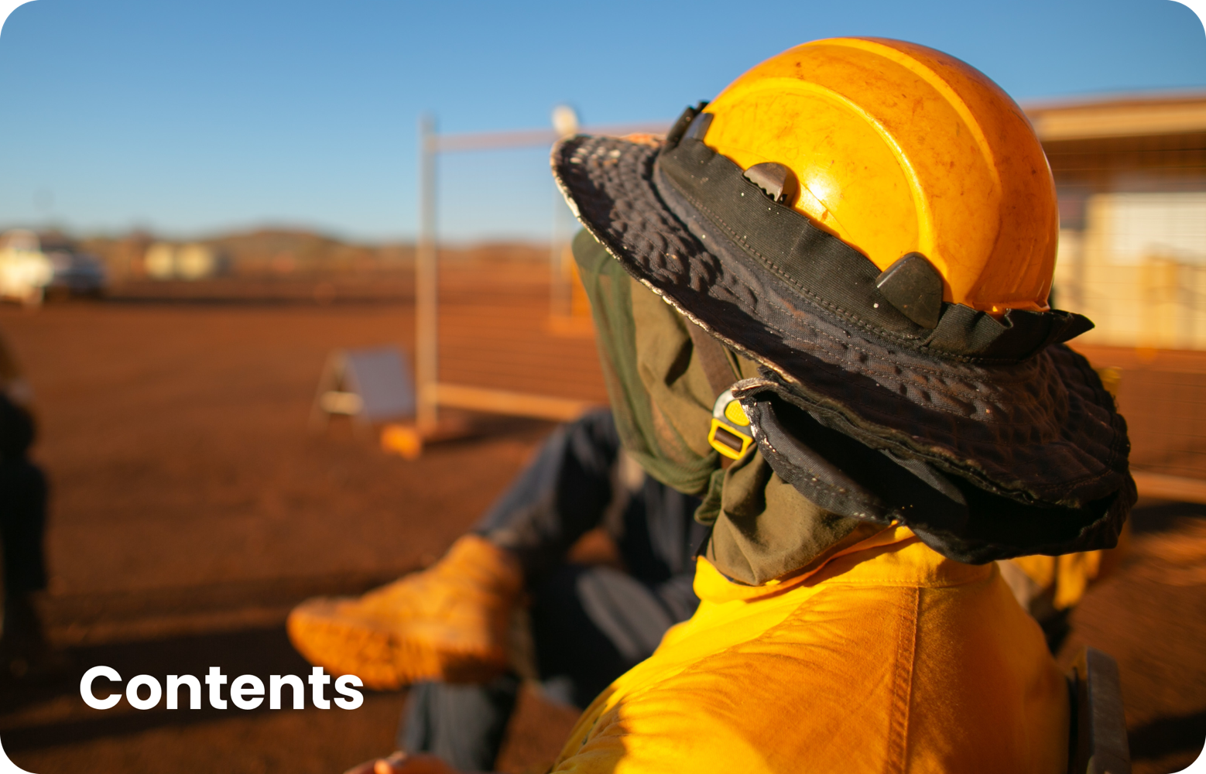

Introduction to Sun Safety 4
Review Procedure 4
References 4
Standards and Guidelines 4
Terminology 5
Document Control 5
Sun Safety 6
Responsibilities 7

Introduction to Sun Safety
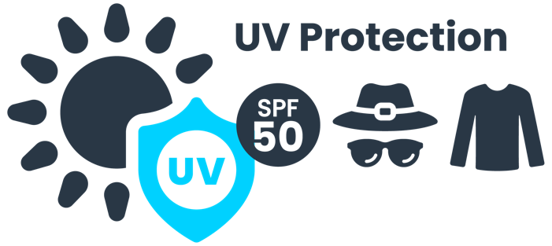 | Australia has the highest incidence of skin cancer in the world - more than 380,000 people are treated for the disease every year.  Workers who work outdoors for all or part of the day have a higher-than-average risk of skin cancer because ultra-violet radiation (UVR) in sunlight (solar UVR) is a known carcinogen. All skin types can be damaged by exposure to solar UVR. Damage is permanent and irreversible, and the level of risk increases with each exposure. Highly reflective surfaces can also reflect harmful levels of UVR.

Review Procedure
The Managing Directors will review the policy as required. The review schedule is directed in response to organisational and/or legislative changes and requirements. The review will be undertaken in consultation with workers, company representatives, and other relevant parties. All relevant persons will be made aware of changes made because of the review.
This policy will be reviewed if:
- there are changes in the workplace that may affect the policy;
- the policy is not effective;
- there are legislative changes that affect the policy;
- there is a breach of this policy.
This policy is reviewed at least annually.

References
How to add your references

Step 1: Click the link below to download your reference list (save it to an appropriate location on your computer).
Step 2. Open the reference list document and Copy and Paste the relevant references into this section.
Step 3. Remember to remove this instruction before adding references.
Legislation and Codes of Practice Reference List Download

Standards and Guidelines
ISO 45001:2018 Occupational Health and Safety Management Systems.
Insert any standards or guidelines applicable to your industry.

Terminology
Abbreviations and Acronyms
AS/NZS: Australian Standards/New Zealand Standards.  PPE: Personal Protective Equipment.  SPF: Sun Protection Factor.  UV: Ultra-violet.  UVR: Ultra-violet Radiation. | - For this policy, no specific references will be made to the terms Health, Safety at Work (HSW), Work Health and Safety (WHS), we will refer to Occupational Health and Safety (OHS) as per the Australian Standard/New Zealand Standard (AS/NZS) International Organisation for Standardisation (ISO) 45001:2018.
Definitions
AS/NZS ISO 45001: International audit tool system intended to audit OHSMS and provide international OHS benchmarks.
SunSmart: is a not-for-profit, health promotion program in Australia that promotes a balance between the benefits and harms of sunlight exposure, most notably including vitamin D and skin cancer.
UV Alert: tells you about the time during the day that you need to be SunSmart. Sun protection times are issued by the Bureau of Meteorology when the UV Index is forecast to reach 3 or above. At that level, it can damage your skin and lead to skin cancer.
UV Index: The UV index is effectively a rough measure of the amount of harmful ultraviolet radiation in the sunlight reaching the Earth's surface at a given location, given the time of year and current atmospheric conditions. UV Index is expressed in terms of the risks that are associated with exposure to that amount of radiation.
We, us, our, our company or the organisation" means {company_name}.
Worker: is a person who carries out work in any capacity for an Organisation, including work as:
- An employee, or  - Outworker, or  - An apprentice or trainee, or  - A student gaining work experience, or  - A volunteer, or | - A person of a prescribed class, or  - A contractor or subcontractor, or  - A worker of a contractor or subcontractor, or  - A worker of a labour-hire company.
Workplace – means a place where work is carried out for a business or undertaking and includes any place where a worker goes or is likely to be while at work. A workplace includes:
- A vehicle, vessel, aircraft, or other mobile structure; and
- Any waters and installations on land, on the bed of any waters or floating on any waters.

Document Control
Distribution Record Register
Copy | Issued to |  |  |  | Controlled Copy |  |  | Authorised by |  | Recipient Signature |  | Issue Date
 |  |  |  |  | Y |  | N
1
2
3
4
Amendment Record Register |  |  |  |  |  |  |  |  | Issue #: 1
 |  |  |  |  |  |  |  |  | Issue Date:
Rev. # |  | Date | Details |  |  | Description of Changes |  |  |  |  | Approved By
 |  |  | Section # | Para. #
1
2
3
4

Sun Safety
Objective
Minimise the harmful impact of UVR for workers when performing work outdoors.
Scope
This policy covers all workers who work outdoors and therefore may be exposed to sun and associated UVR sufficiently to cause a risk to health.
Policy
{company_name} will take adequate steps to reduce the known health risks associated with exposure to solar UVR for outdoor workers.
To reduce the risk of injury or illness from exposure to UVR, {company_name} has developed a Sun Safety program to:
- organise work to avoid the UV peak of the day wherever possible;
- provide natural or artificial shade wherever possible;
- provide appropriate protective clothing (covering as much skin as possible, SPF rating of 30+, protective glasses, broad-brimmed hats or caps with neck-flaps);
- ensure all protective equipment meets Cancer Council sun protection AS/NZS;
- provide sunscreen (minimum of SPF 30+);
- develop training and awareness programs to include:
  - health effects of exposure to UVR and why outdoor workers are a high-risk group;
  - factors affecting levels of UVR;
  - correct use of various sun protection measures;
  - early detection of possible skin cancers;
  - UVR hazard and risk identification.

Responsibilities
{company_name} has the responsibility to:
- conduct a risk assessment, in consultation with workers to identify any workers who have a risk of exposure to UVR, and work situations where exposure to solar UVR or reflected UVR may occur;

- reduce workers' exposure to UVR by requiring the use of sun protection control measures by outdoor workers when the UV Index is 3 and above and at all times when working near highly reflective surfaces.

Supervisors/Managers have a responsibility to:
- ensure workers are familiar with our Sun Safety Policy and procedure and are trained and competent in the correct use of sun protection PPE and clothing;

- advise workers that the SunSmart UV Alert is issued whenever the UV Index is forecast to reach 3 and above, and use the period displayed to inform workers when it is necessary to use sun protection control measures while working outdoors;

- ensure all workers at risk from exposure to UVR have access to adequate and appropriate PPE and sun-protective clothing;

- ensure all workers wear and apply sun protection PPE and clothing when required;

- monitor and review the Sun Safety Policy and procedure regularly.
Workers have a responsibility to:
- take reasonable care for their own health regarding sun protection;

- identify and report UVR risks encountered when carrying out outdoor work;

- correctly wear and use sun protection PPE and clothing during work hours;

- wear a combination of long sleeve shirt and full-length trousers if exposed to UVR for more than 15 continuous minutes in a period unless an exception has been authorised by risk assessment;

- not to intentionally misuse or damage sun protection PPE or clothing;

- inform their manager/supervisor of any damage to, defect in, or need to clean or decontaminate any sun protection PPE or clothing.

Signature: | Date:
(To be signed by Director/Business Owner)

